Start: 7:05PM 11-15-23 BC

DHF Things to Implement

-put any research links or info on the proper research links folder

-sign gantt charts from now on

-add numbering system for DHF

-Miguel created a doc that brings up concerns to yongheng

-added user needs history file

-added a revision for the user needs statement

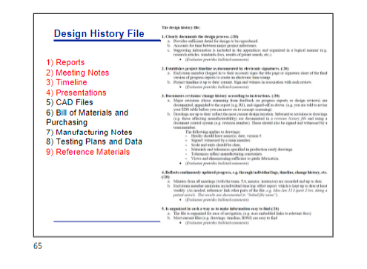

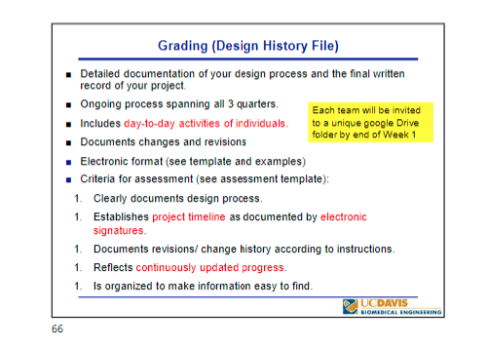

-set up meeting with Yongheng to discuss current state of the project

Revised Statement:

"Our senior design team is currently investigating the challenges associated with maintaining the proper closure of lab refrigerator doors. We understand that ensuring doors are consistently closed is crucial to prevent potential issues such as temperature fluctuations and sample integrity compromises. This survey aims to gather insights into the experiences and concerns of individuals who use lab refrigerators."

Survey Questions:

* How often do you encounter challenges related to lab refrigerator doors being unintentionally left open in your work environment?
* Can you share any specific instances or scenarios where lab refrigerator doors being left open have caused issues in your research or work processes?
* What, in your opinion, are the most significant risks or consequences associated with lab refrigerator doors not being securely closed?
* Are there any specific factors or circumstances that contribute to the likelihood of lab refrigerator doors being left open in your experience?
* How do you currently address or mitigate the risk of lab refrigerator doors being left open in your workspace?
* Are there any features or improvements you would like to see in a solution that ensures lab refrigerator doors are consistently closed?
* Can you describe any existing practices or strategies in your laboratory to promote the proper closure of lab refrigerator doors?
* Are there any additional measures or solutions you think could be effective in addressing the challenge of keeping lab refrigerator doors closed?
* **How would you describe the challenges related to lab refrigerator management in your work environment?**
* **Can you share any specific instances or scenarios where lab refrigerator doors being open have caused issues or disruptions in your research or work processes?**
* In your opinion, what are the most significant risks or consequences associated with lab refrigerator doors not being managed effectively?
* What factors or circumstances do you believe contribute to lab refrigerator doors being left open in your experience?
* How do you currently address or mitigate the risk of lab refrigerator doors being unintentionally left open in your workspace?
* Are there any specific features or improvements you would like to see in a solution that enhances the management of lab refrigerator doors?
* Can you describe any existing practices or strategies in your laboratory to promote effective lab refrigerator door management?
* Are there any additional measures or solutions you think could be effective in addressing the challenge of managing lab refrigerator doors?

**Adam**

**Yongheng**

End